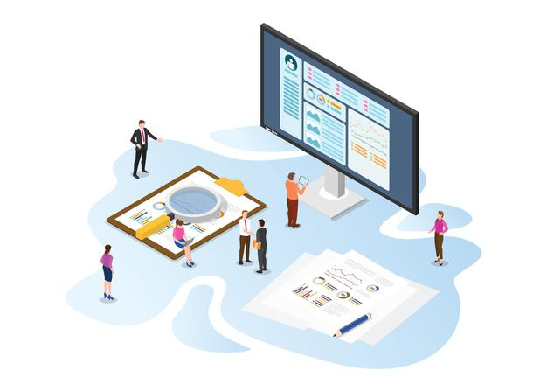­

**A.A.GOVERNMENT ARTS COLLEGE MUSIRI.**

**TEAM ID:**

**NM2023TMID08259**

**TEAM LEADER:**

**AKESH KUMAR K : 71B02FA25239602834640A4108F1819F**

**MEMBERS:**

1. **BALAKUMAR S : 34706AEC459097391D34F3DFBBE49F72**
2. **GOETHAM D : D57CF4E718DC49A9C5943B56CCFF9046**
3. **LOGESH KUMAR A : CDDAC4012521322ACDA43E24178B07A5**

**SUBMITTED BY**

**NAAN MUDHALVAN PROJECT – III BSC MATHEMATICS**

**TOPIC:**

**UNVEILING MARKET INSIGHTS: ANALYSING SPENDING BEHAVIOUR AND IDENTIFYING OPPURTUNITIES FOR GROWTH.**

**Affiliated to Bharathidasan University, Tiruchirappalli.**

**INTRODUCTION**

The spend analysis process investigates this spending behavior data to make key business decisions using purchase data, direct spend analytics, market segmentation, and predictive modeling tools.

Opportunity indentification is when an individual realizes a business idea with good returns that has not been discovered. It requires keen scanning of the business environment , being alert about the changing information, and the ability to use the information effectively.

Growth is physical change and increase in size. It can be measured quantitatively. Indicators of growth include height, weight, bone size and dentition. The pattern of physiologic growth is similar for all people. However, growth rates vary during different stages of growth and development.

Wholesaling or distributing is the sale of goods or merchandise to retailer to industrial, commercial, institutional or other professional businessman to other wholesalers (wholesale businesses) and related subordinated services.

**Milestone 1: Define Problem / Problem Understanding**

**Activity 1:**

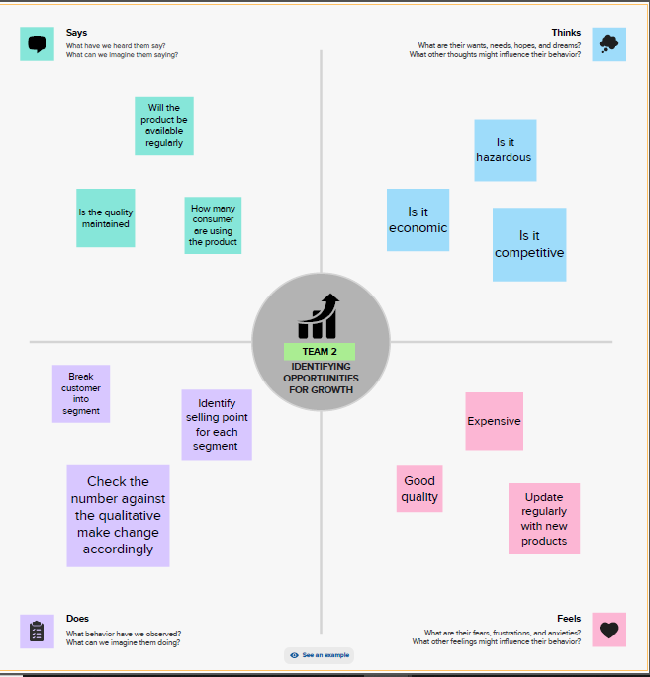

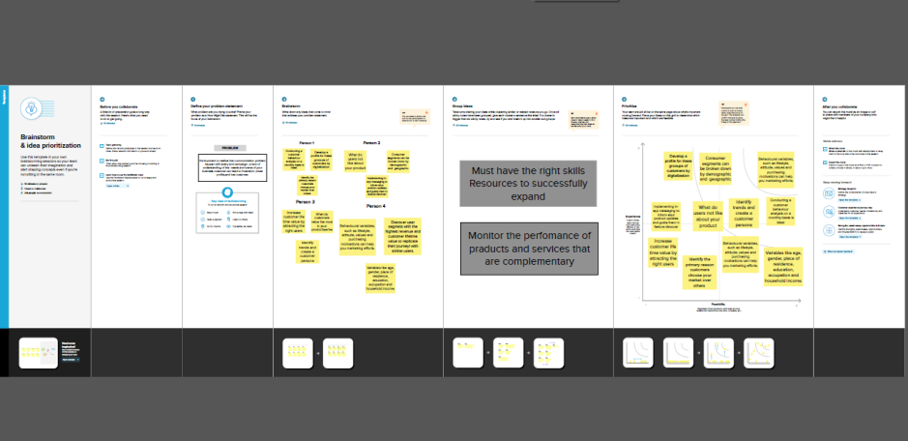**Activity 2: Requirement:**

**REFERENCE:**

* **Al-Bakery, Thamer, (2006). *Marketing Communications and Promotion*, The first edition, Dar Al-Hamed for publishing and Distribution, Amman, Jordan.**
* **Barabba, V. P., & Zaltman, G. (1991). *Hearing the Voice of the Market*: Competitive**

**Advantage through Creative Use of Market Information. Dar Al-Hamed for Publishing and Distribution, Amman, Jordan.**

* **Danaher, P. J., Hardie, B., Putsis, W. P., (2001). Marketing-mix variables and the diffusion of sucessive generations of a technological innovation. *Journal of Marketing Research*, 38 (4), 501– 514.**
* **Dekeba, Alemayehu. 2003. ―Basic of Marketing Research Methods‖ *URL: http://www.globusz.com/ebooks/MarketingResearch/index.htm Econometrica* 76 (5), 1017–1074.**
* **Nevo, A., (2001). Measuring market power in the ready-to-eat cereal industry. *Econometrica* 69 (2), 307–342.**

**Milestone 2: Data Collection & Extraction**

**Activity 1: Collect the dateset**

Please use the link to download the dataset:

<https://drive.google.com/file/d/16Lwm4oId6LUnFGXWflMMYm10zynmvuE0/view>

**Activity 1.1: Understand data**

Wholesaler Customer Data.csv

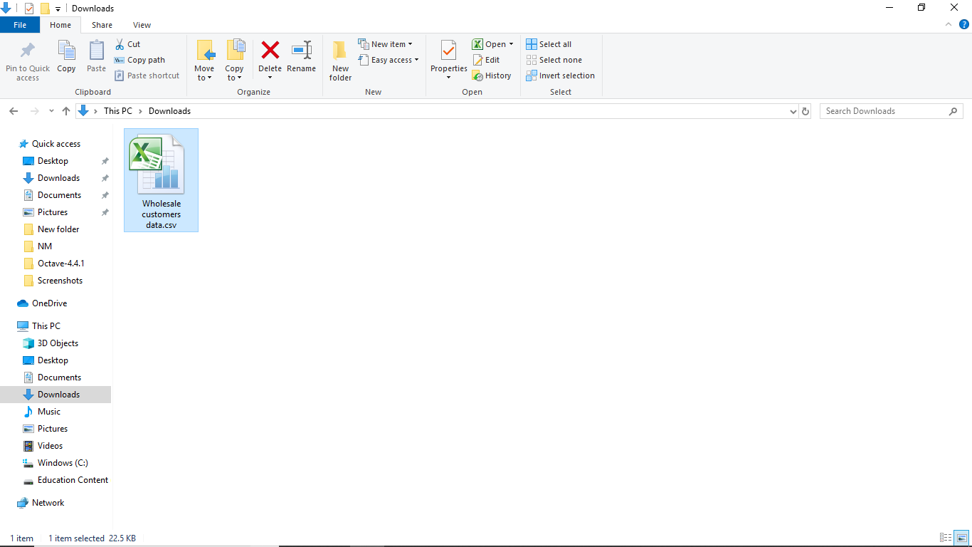

**Column description**

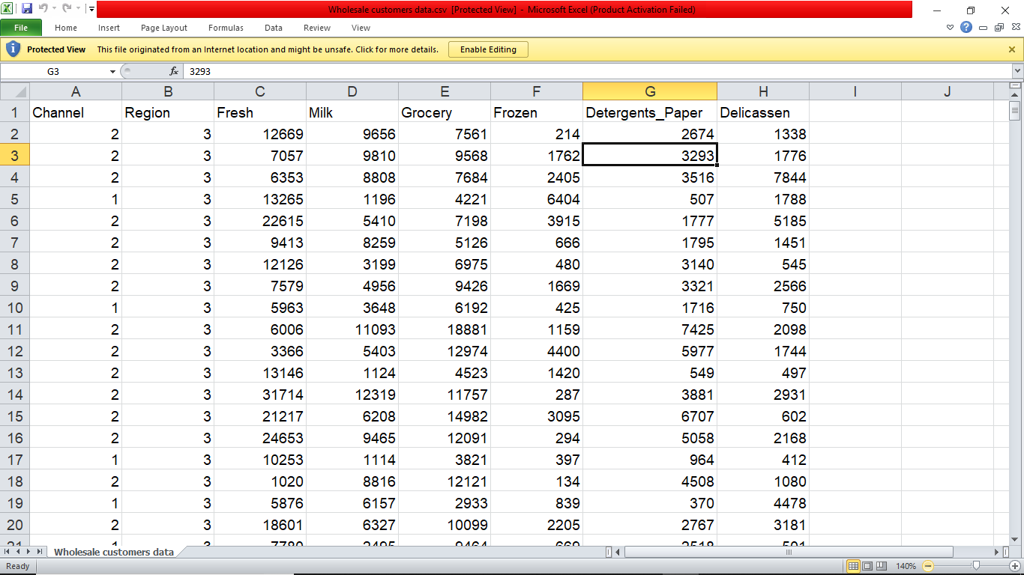

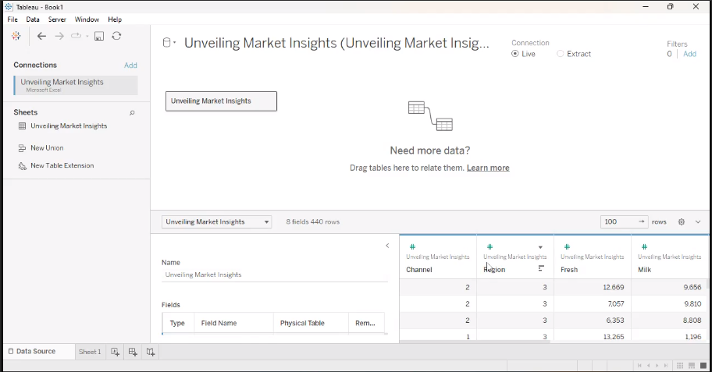**Activity 2: Connecting to Tableau.**

**Milestone 3: Data Perparation**

This process helps to make the data easily understandable and ready for creating visualization gain insights into performance and efficiency.

**Milestone 4: Data Visualization**

**Activity 1: No of Unique Visualizations**

These visualizations can be used to compare performance, track changes over time, and show distribution, and relationships between variables.

**Activity 1.1: KPI’s**

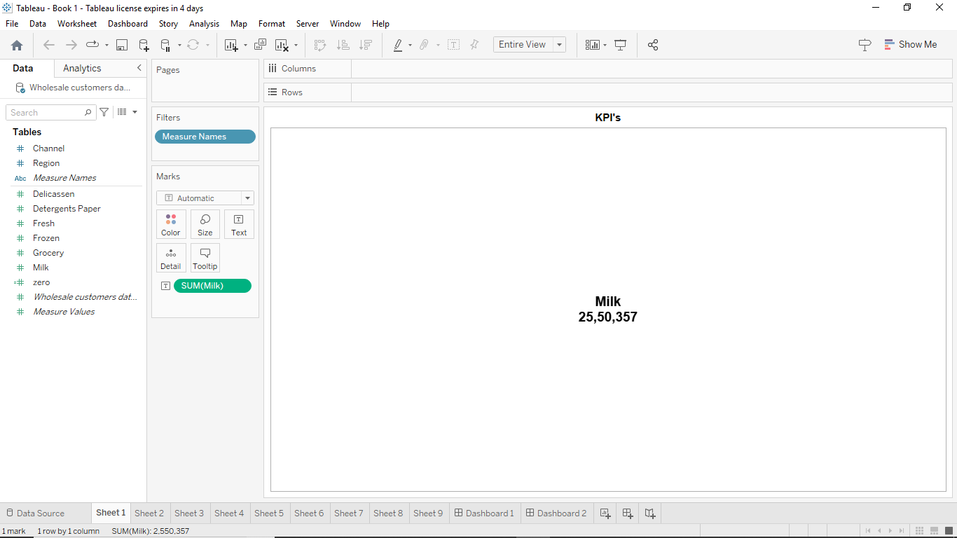

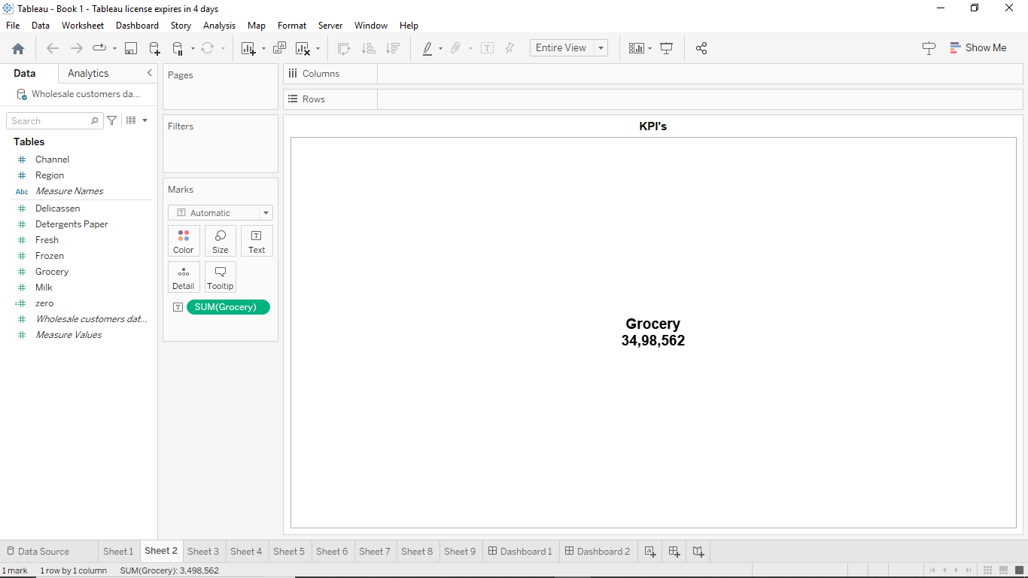

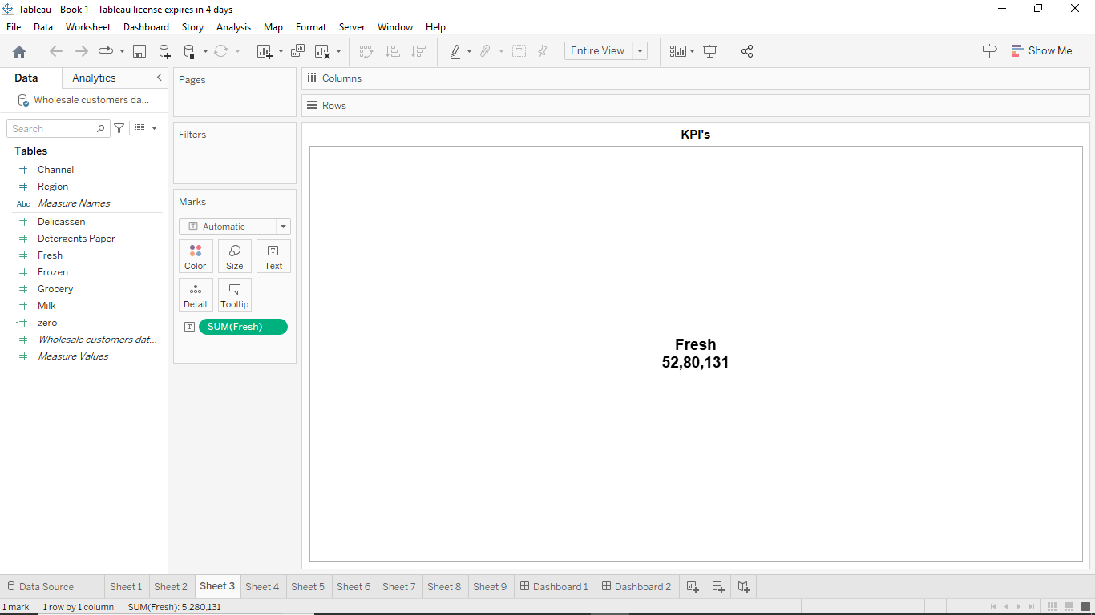

**Activity 1.2: Region Wise Detergent paper and grocery**

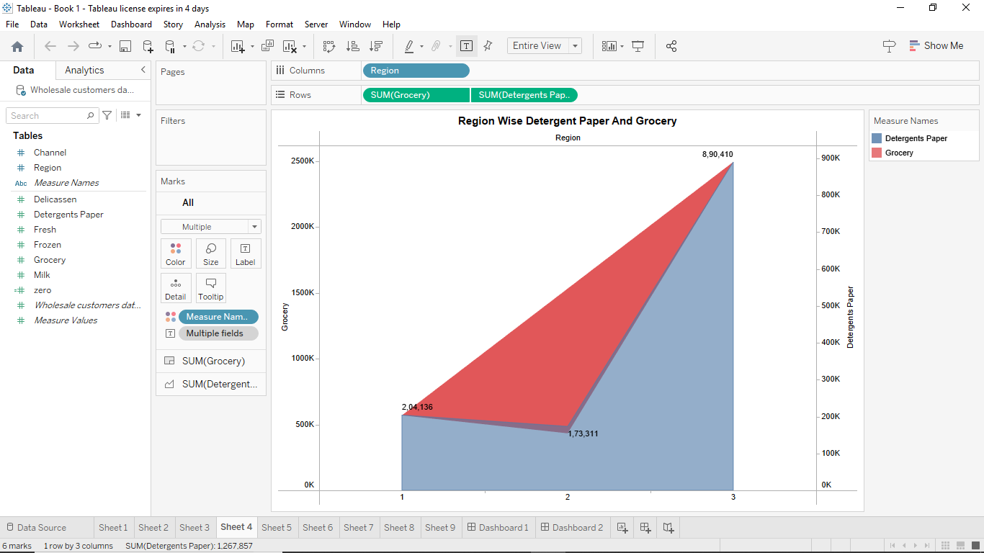

**Activity 1.3: Region wise Milk**

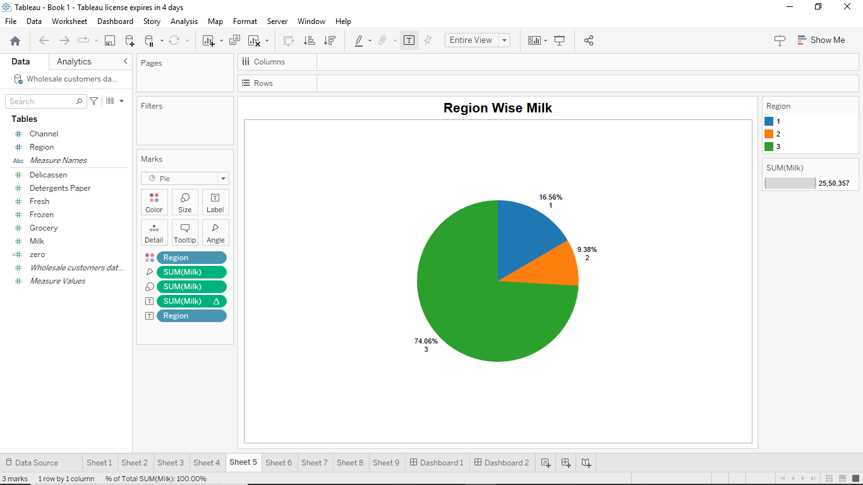

**Activity 1.4: Channel wise frozen and Delicatessen**

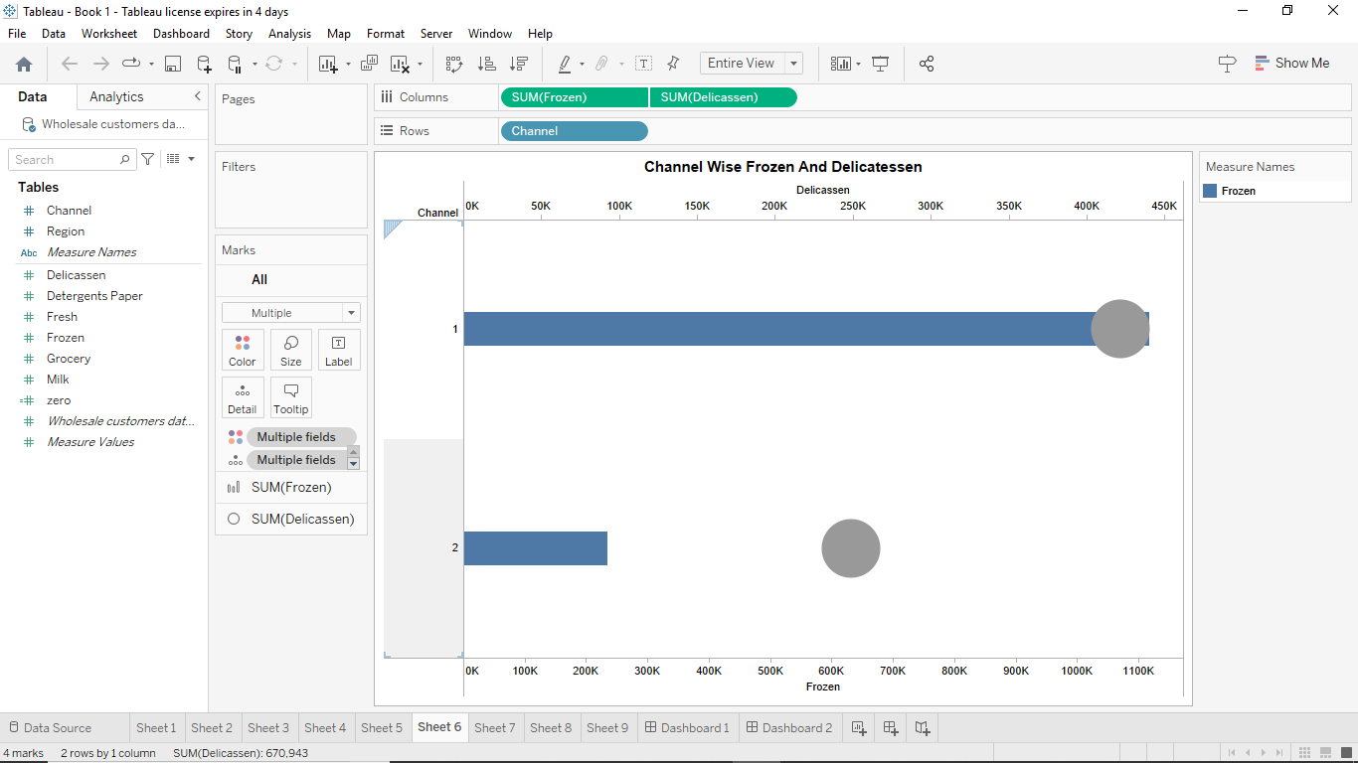

**Activity 1.5: Region wise Delicatessen and Detergent paper**

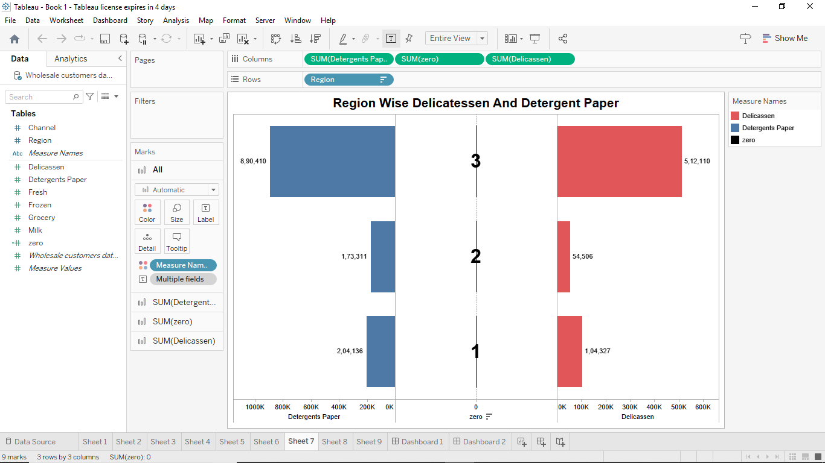

**Activity 1.6: Channel wise grocery and Detergent paper**

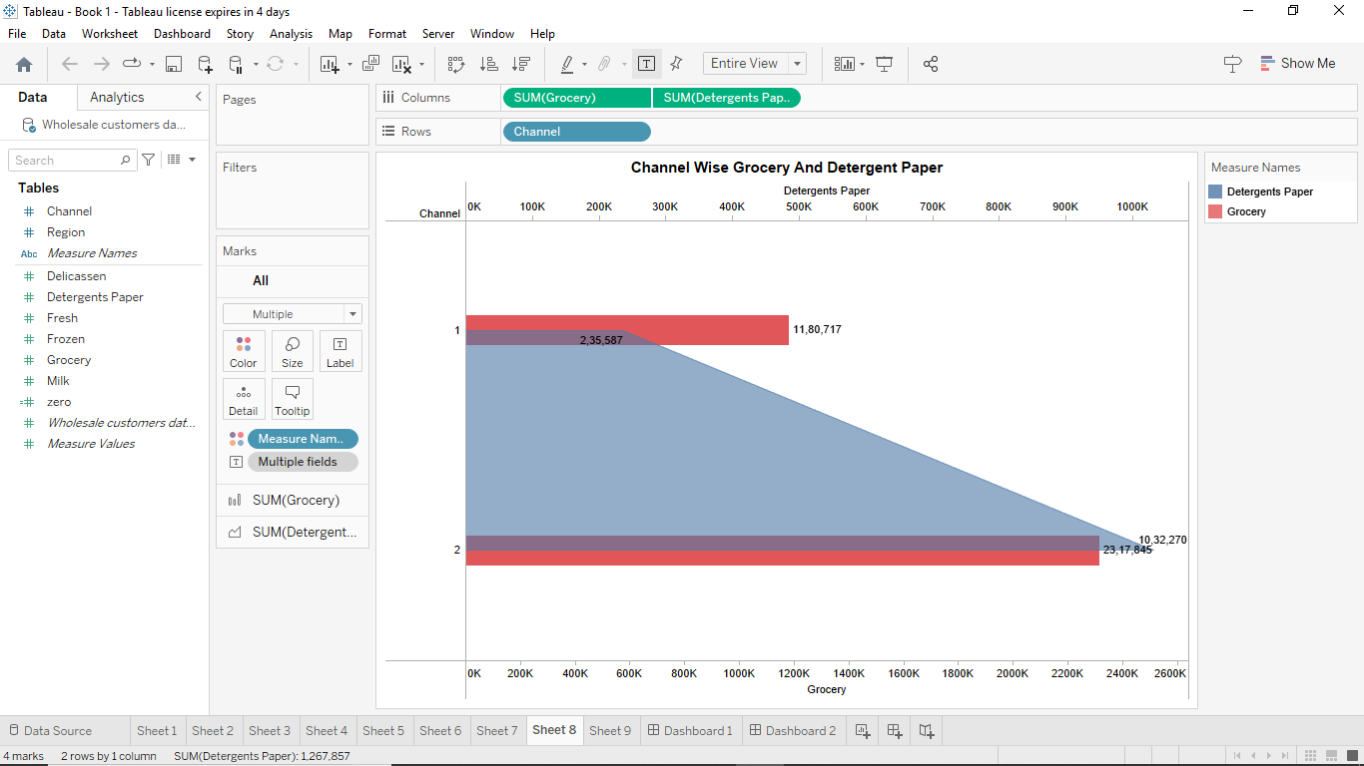

**Activity 1.7: Region Wise Delicatessen**

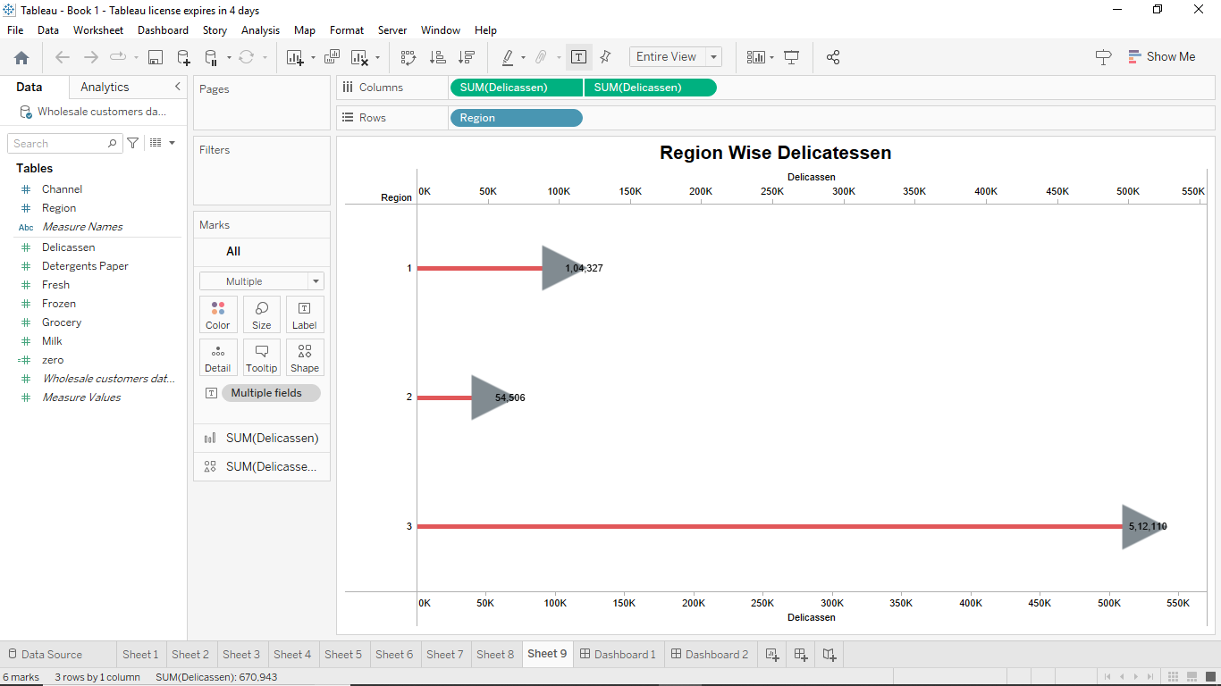

**Milestone 5: Dashboard**

**Activity :1- Responsive and Design of Dashboard.**

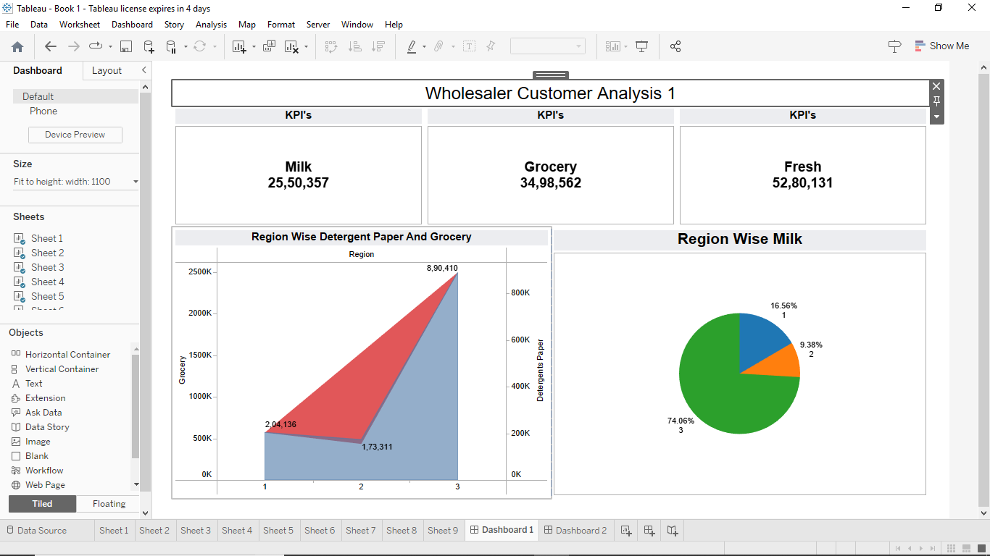

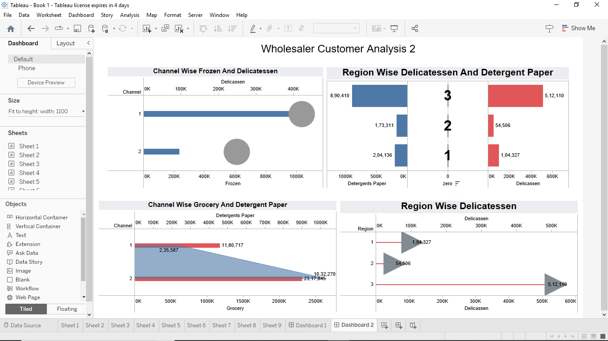

**Milestone 6: Story**

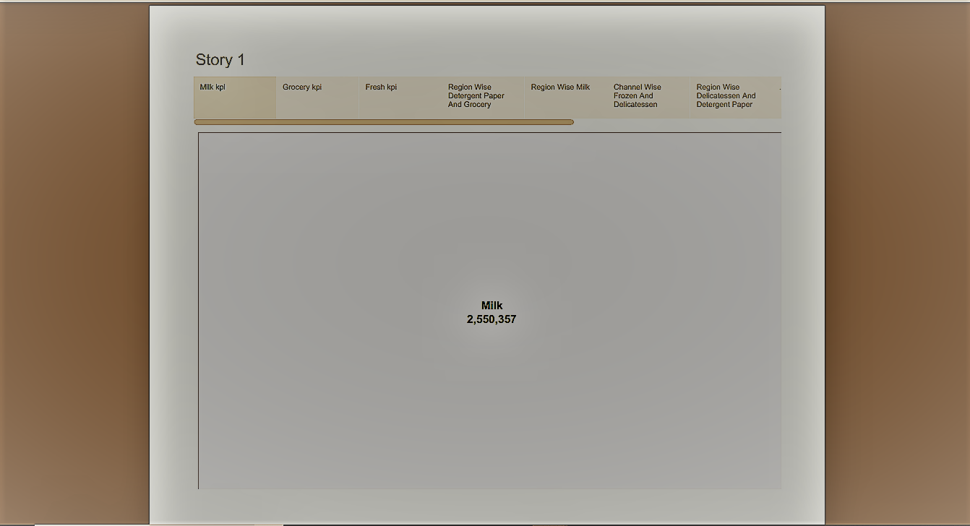

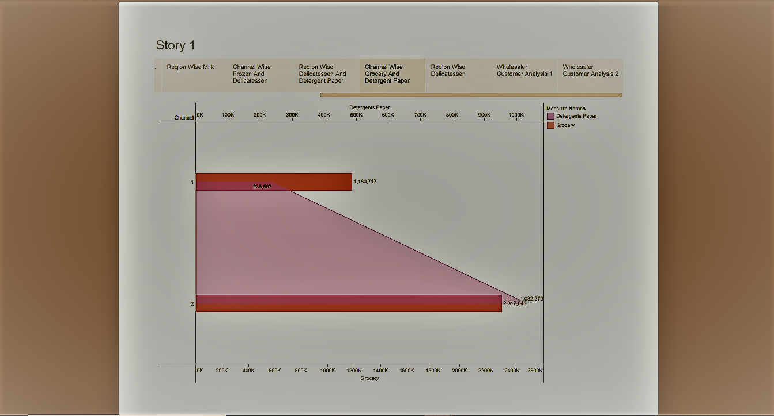

**Milestone 8: Publishing**

**Dashboard 1:**

<https://public.tableau.com/views/Dashboard1_16952779416320/Dashboard1?:language=en-US&publish=yes&:display_count=n&:origin=viz_share_link>

**Dashboard 2:**

<https://public.tableau.com/views/Dashboard2_16952802823250/Dashboard2?:language=en-US&publish=yes&:display_count=n&:origin=viz_share_link>

**Story:**

<https://public.tableau.com/views/Story_16952804985180/Story1?:language=en-US&publish=yes&:display_count=n&:origin=viz_share_link>

**CONCLUSION:**

Market research analysis is a powerful tool for business to gain a competitive edge in today’s dynamic marketplace. By harnessing the power of data and extracting meaningful insights, companies can make informed decisions, understand consumer needs, and identify growth opportunities. Effective market research analysis enable businesses to stay relevant, innovative, and successful in their respective industries.

To make your market research analysis to the next level and drive your business forward, request a demo from Aim Technologies. Our cutting-edge solution and expertise in market research and provide you with actionable insights that will propel your business to new height. Don’t miss out on the opportunity to make data driven decision and stay ahead of the competition.